**Critical Play Report – Action Adventure – Another World**

Composer: Gordon (Cunbo Li)

Email: [gordon.lee@nyu.edu](mailto:gordon.lee@nyu.edu) or [cl3846@nyu.edu](mailto:cl3846@nyu.edu)

*Another World* is a very interesting game that I’ve ever played. I love this game very much not only because it looks very beautiful but also needs the player acquired some skills for puzzle solving and exploring the game world.

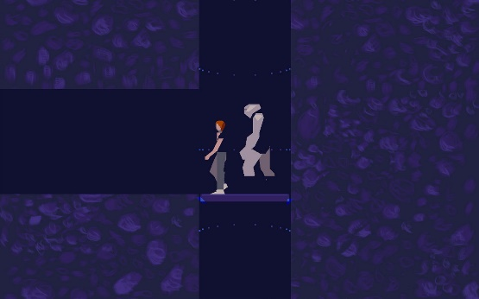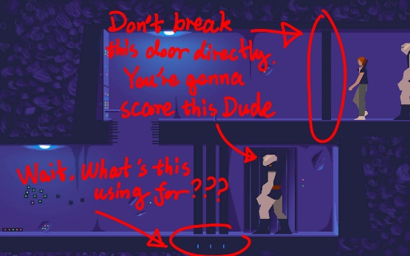In order to walk through the game and reach the end of the story, the player should know how to reasonably use skills – inspection, memory and rhythm. That is to say, the player has to pay attention to every detail and objects in the game environment. Collecting useful information or inspiration to solve puzzles or fight against the enemies. Figuring out the objects features and memorizing locations of traps in the game world. For example, during the main character – Lester escaping from the jail, he reaches a door that is guarding by an alien enemy (showing in Figure01). If he directly breaks the wall, the enemy guard will open the door immediately and shoot the laser gun. Lester will no longer have a chance to go through and reach the room to the left. But, wait, I notice something flashing. Something looks like transferring information or power to the door next to the alien enemy. Lester goes back to the elevator and down to the lower floor (showing in Figure02). He enters the lower room and kills the enemy. We can easily notice that something transferring out of the source (showing in Figure03). I guess this is the power that connecting to the door next to the enemy in the upper floor. Once Lester shoots to the source, the bright and flashing transferring line are dimed out. Now Lester can go back to the upper room. The enemy guard cannot open the door and shoot his gun immediately when Lester breakthroughs the wall in front of him. The enemy has to break the doors (3-wall-door I think) one by one. Now, Lester and his alien partner acquire time to go through this room and enters to another one at the left.

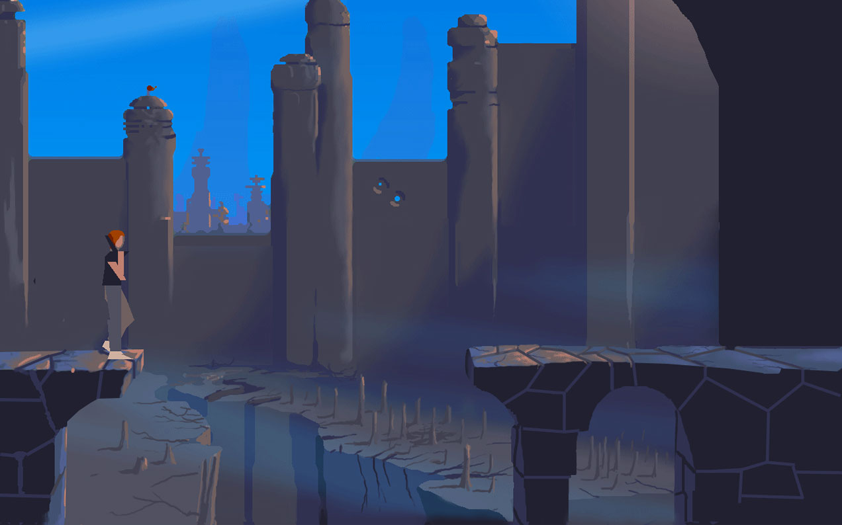

Figure 02

Figure 03

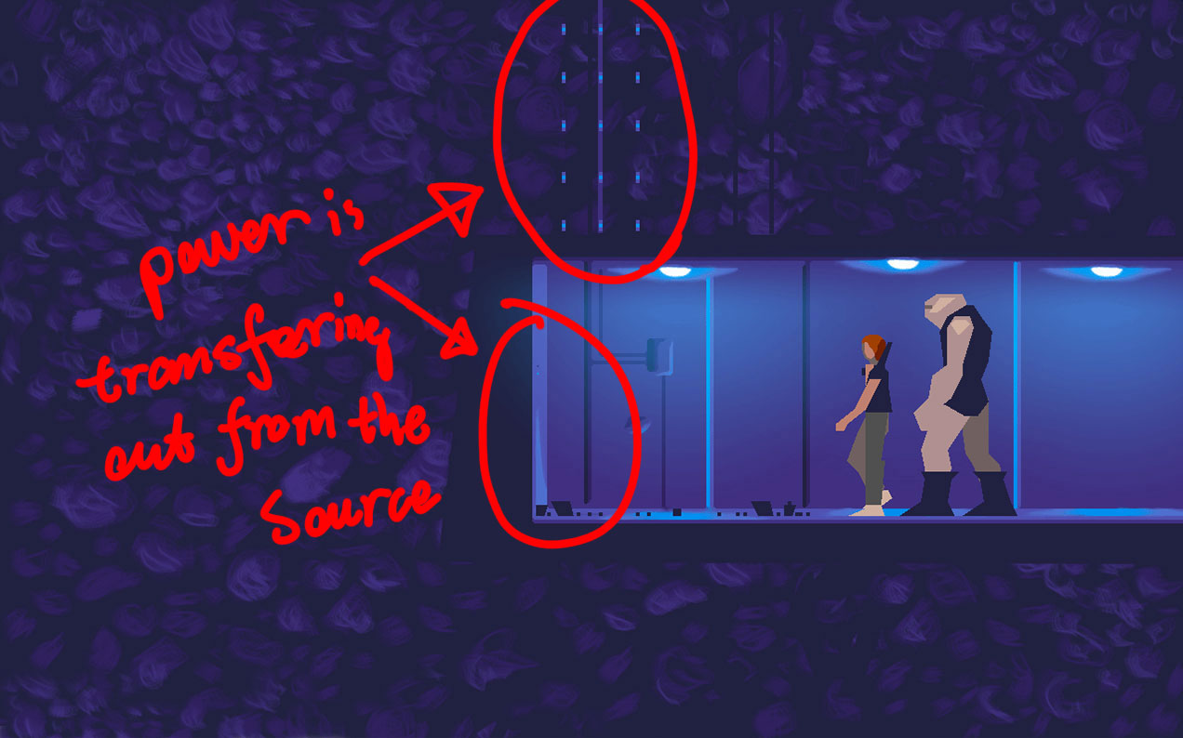

Figure 1

Besides the inspection skills in playing *Another World*, memorizing traps is also very important for the player successfully goes through the game world. For an instance, when Lester reaches the broken bridge as showing in Figure04. If Lester falls off the edge. He will be stabbed by the sharpen rocks on the ground. The solution to this trap is jumping out of the edge. There are a lot of traps in the game world. The player needs to try to remember their locations in case of accidentally die in the gameplay.

Figure 04

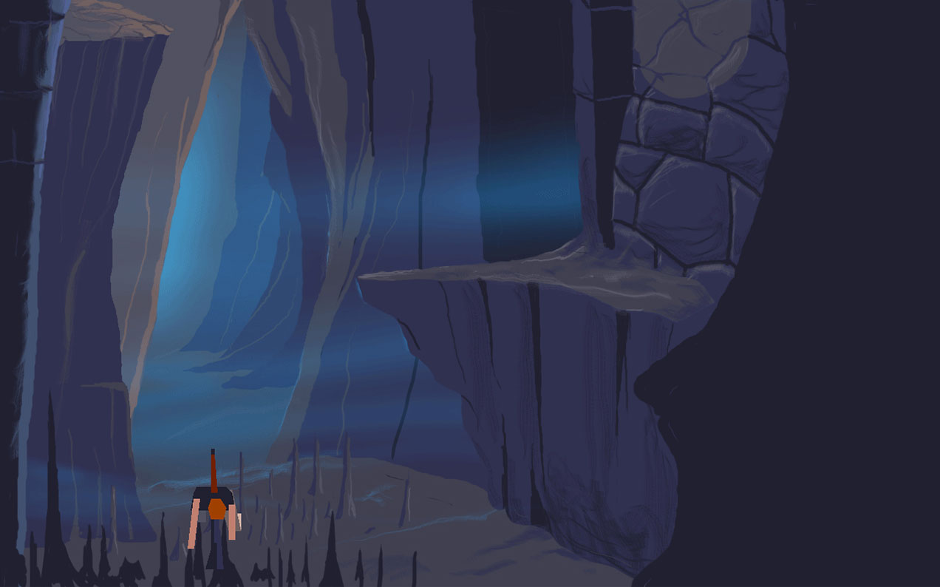

Figure 05

The last important skills in playing *Another World* is that rhythm of the obstacles. To be more specific, the player should know the frequencies of some fatal objects or traps (I think everything, every object and obstacle in *Another World* are fatal). Lester needs to avoid deadly steam in the pipe (showing in Figure06). In order to smoothly go through the pipe. The player has to figure out the frequencies of these steam leakage. Another example is falling rocks in the cave (showing in Figure07). Lester has to avoid falling rocks bombard in the cave. These falling rocks are very fast, but it’s easy to find out their falling frequency if Lester can find somewhere safety in the cave. Once the player finds out the rhythm of rocks. It is not hard to go across the falling rocks.

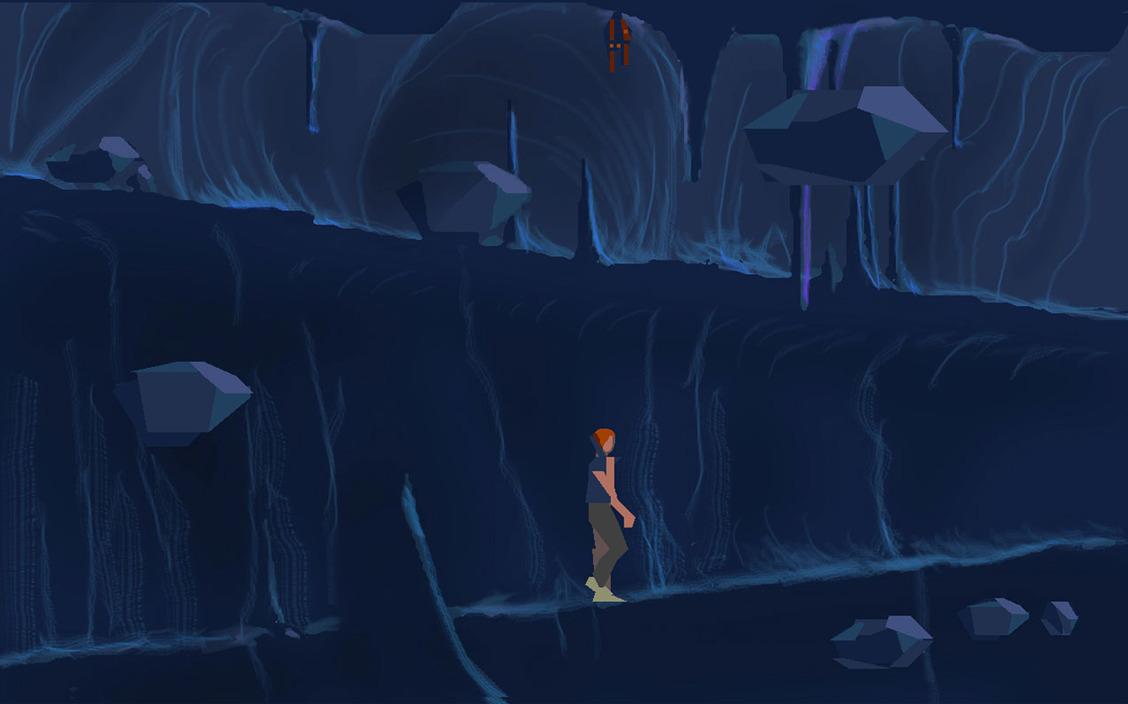

Figure 06

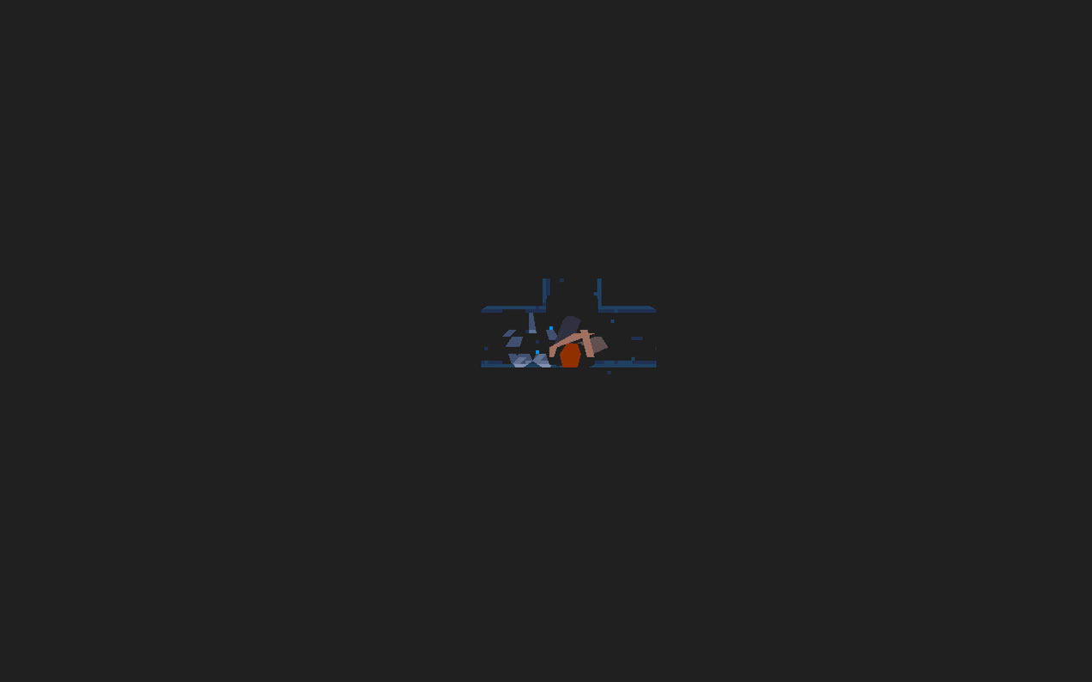

In summary based on the above discussion, I believe that in order to successfully walk through the entire gameplay of *Another World*, the player should have some skills of inspecting details and information that in the game world, memorizing traps locations and figuring out the rhythm of objects or obstacles. With these useful skills, the player will enjoy this game very much and smoothly reach the end of the story that narrates in *Another World*.

Figure 07